DAGV 1700 Unit 4 Milestone (Laura Richardson)
- Screenshots of your implementation
  - Before my player picks up the key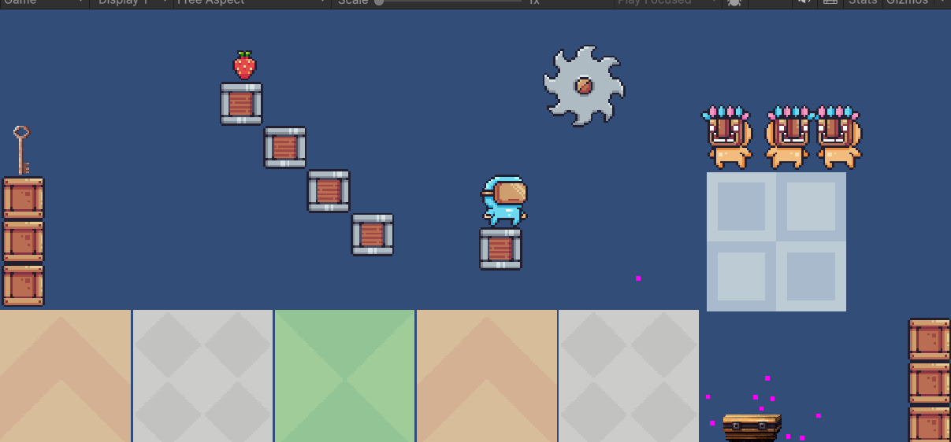
  - Player picks up the key and it disappears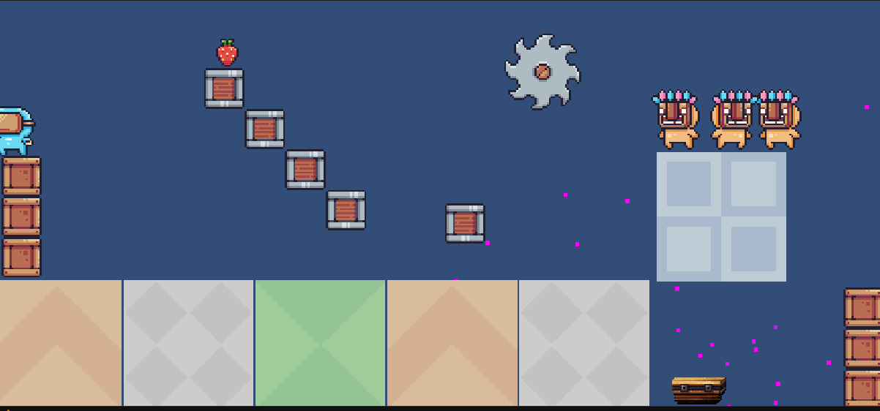
  - Key is attached to player 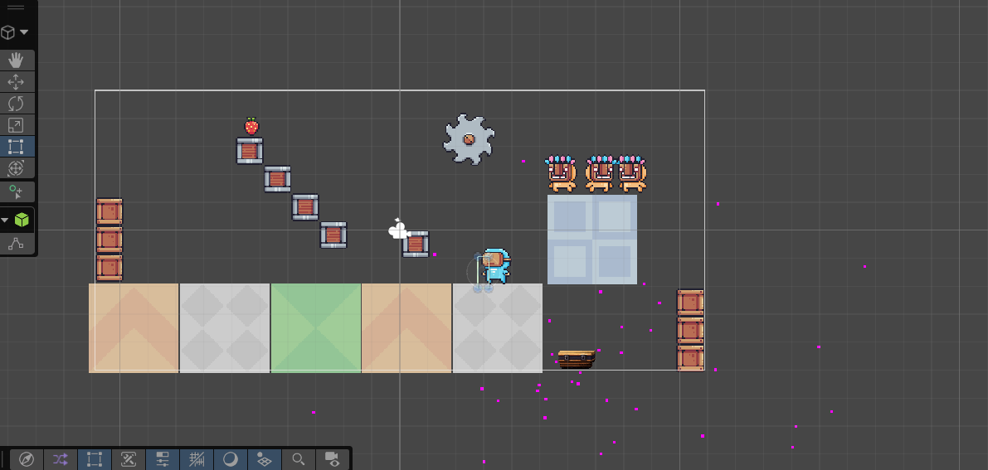
  - Player brings key to chest, chest plays animation of it opening, and more particles explode from the chest in celebration 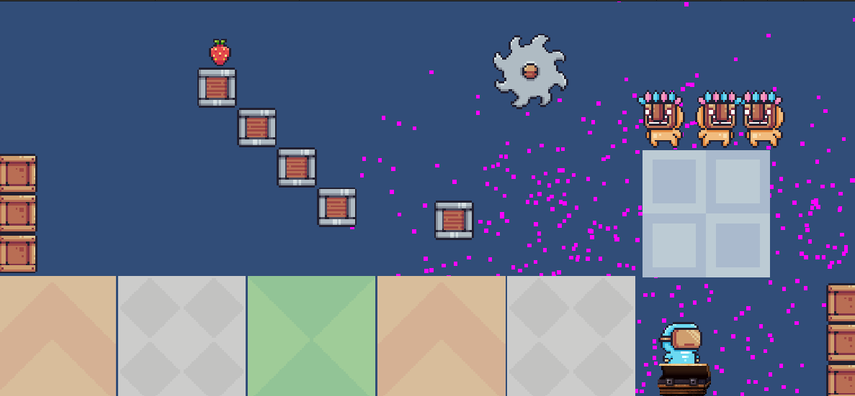
- Your 200-word write-up
  - This was fun to figure out how to do it. I learned how to run and Animation, to where my guy looks like he’s breathing, and well as his enemies. That was difficult to figure out, and I had to look up videos on YouTube on how to do it, because I couldn’t find that step on canvas. Making the saw run, I forgot where I had to select loop playback, so that took me a second to figure out why it wasn’t working properly. I followed the video on canvas decently well on how to make the key disappear, attach it to my player, and then bring it to the chest. Figuring out how to run an animation once the match id was true was difficult for me for whatever reason, but I figured it out. I decided that the chest opening animation was a little lackluster, so I made a particle system emit once the match id was confirmed as well. I have never done the match id before, so I tested it to make sure the chest wouldn’t open without the key, and it passed the test. Honestly, a fun little system. I still got a couple bugs to work out, but I liked seeing the basic ideas implemented on the canvas videos, and having the freedom to learn how to do things and make it my own.
- A link to your GitHub repository
  - https://github.com/richar65/Essentials
- A link to your 1-minute walkthrough video (unlisted YouTube link preferred)
  - https://youtu.be/8shXiowTh68?si=o6APvUF5-5PIBO-M

